Assignment 1

ATRIJ ROY. UG 2 IT A3. ROLL NO:- 002311001086

1. Show the details of all employees.

**SELECT * FROM EMP;**

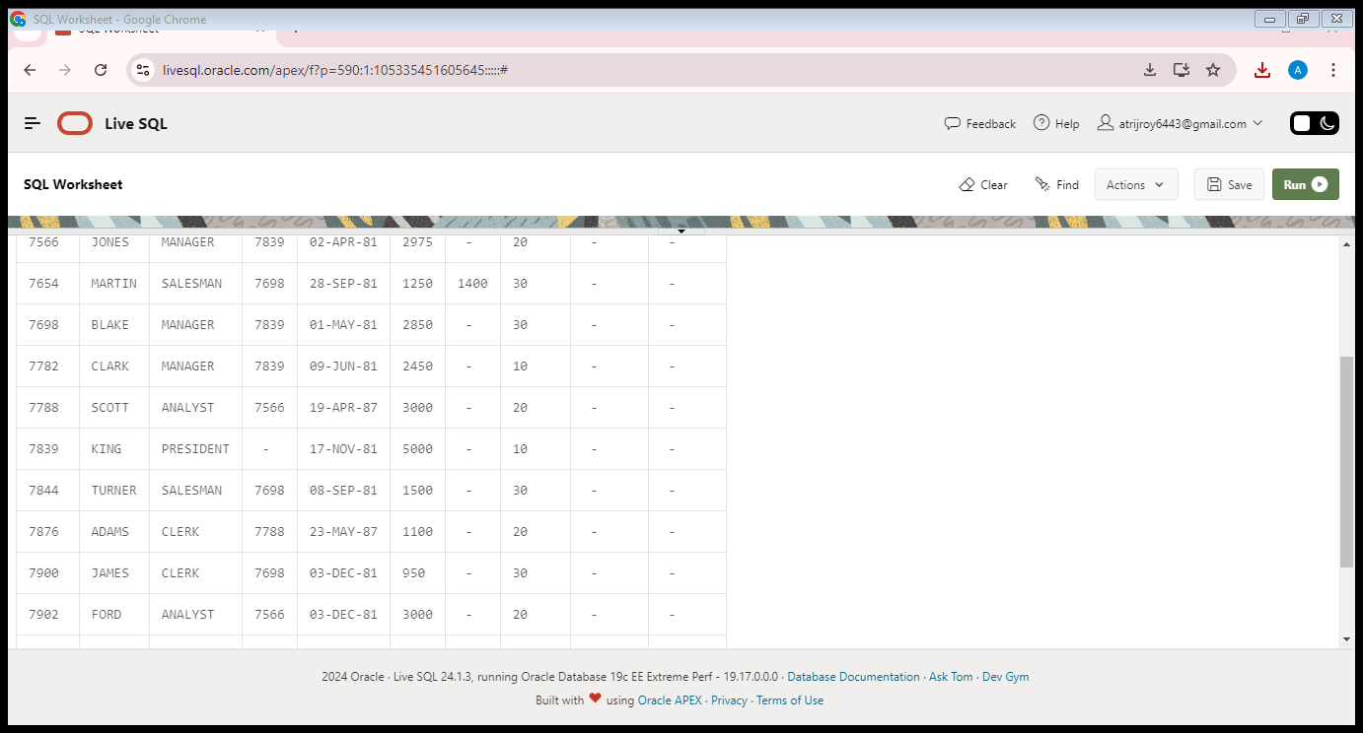

1. Show the department no. and name of all departments.

**SELECT DEPTNO, DNAME FROM DEPT;**

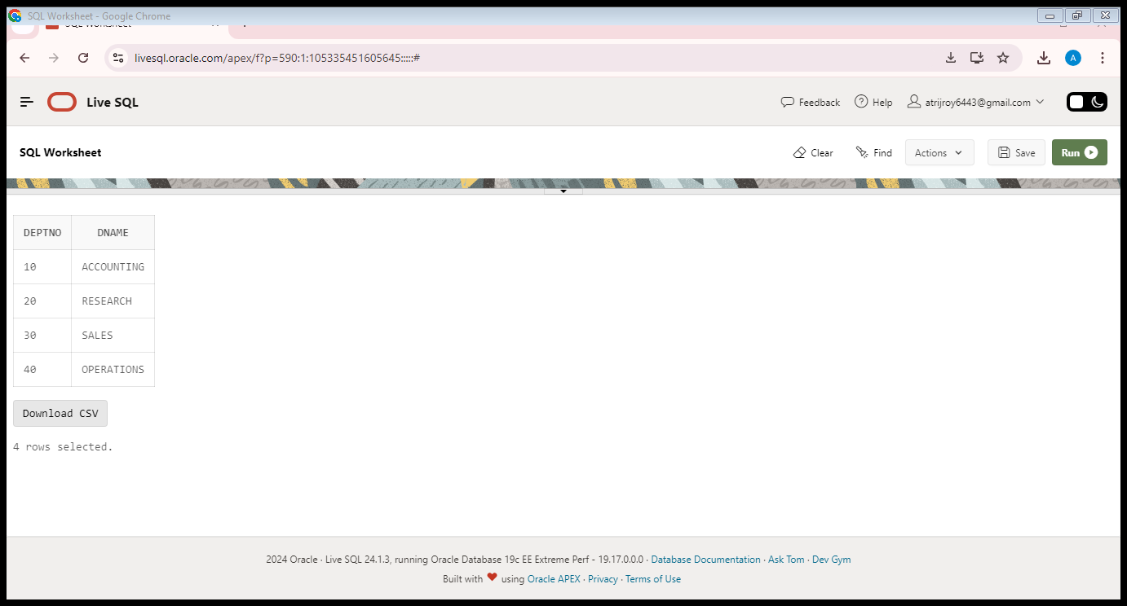

1. Display the employee id, name and department no of all employees whose department no is 20.

**SELECT EMPNO, ENAME, DEPTNO FROM EMP WHERE DEPTNO=20;**

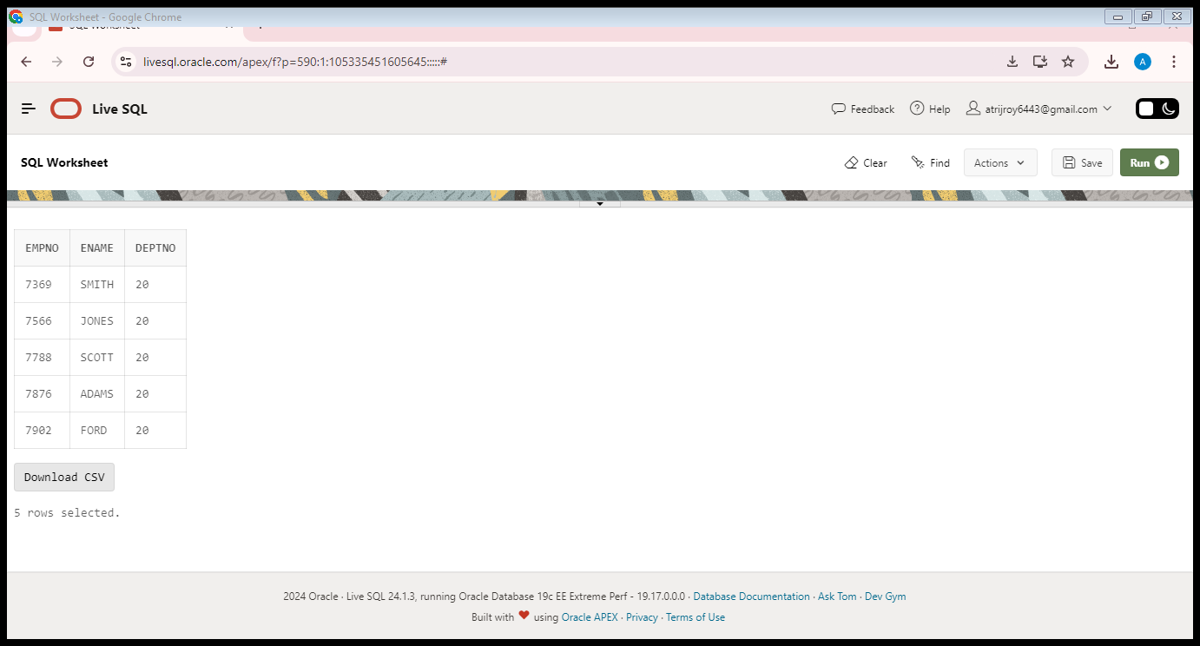

1. Display the details of all employees where department no should be in descending order.

**SELECT * FROM EMP ORDER BY DEPTNO DESC;**

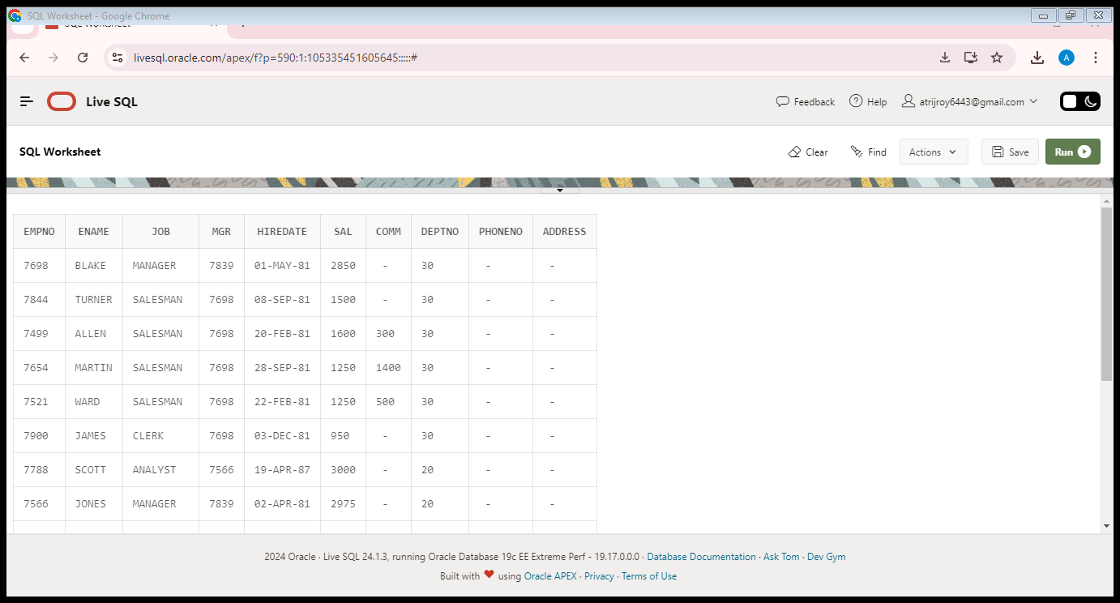

1. Show all available jobs in the employee table.

**SELECT DISTINCT JOB FROM EMP;**

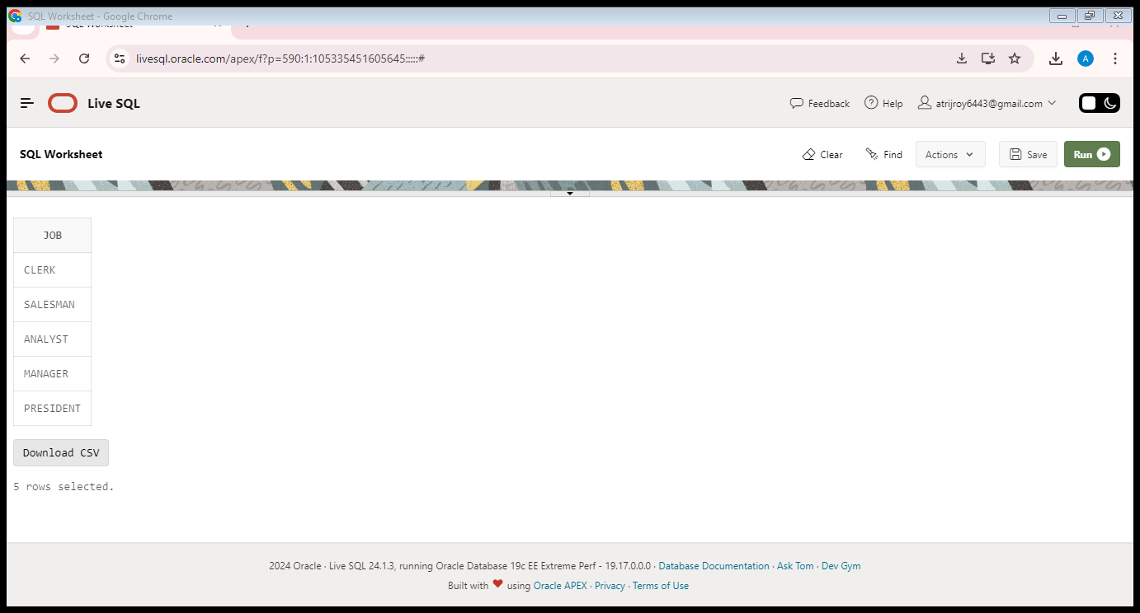

1. Show the name, Annual Salary and department no of employees who works as a clerk in department 20.

**UPDATE EMP**

**SET COMM = 0 WHERE COMM IS NULL;**

**SELECT ENAME, 12*SAL+COMM AS ANNUALSALARY, DEPTNO FROM EMP WHERE JOB = 'CLERK' AND DEPTNO=20;**

**UPDATE EMP**

**SET COMM = NULL WHERE COMM = 0;**

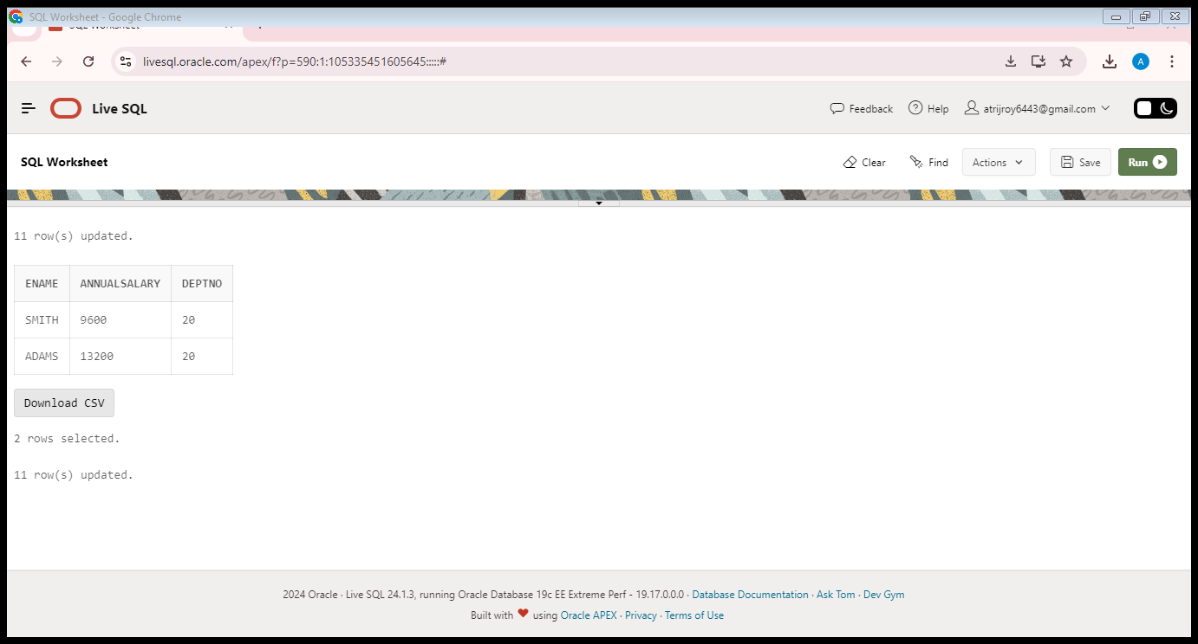

1. Show the name and HIRED date of those employee whose name start with ‘S’ or second character is ‘C’.

**SELECT ENAME, HIREDATE FROM EMP WHERE ENAME LIKE 'S%' OR ENAME LIKE '_C%';**

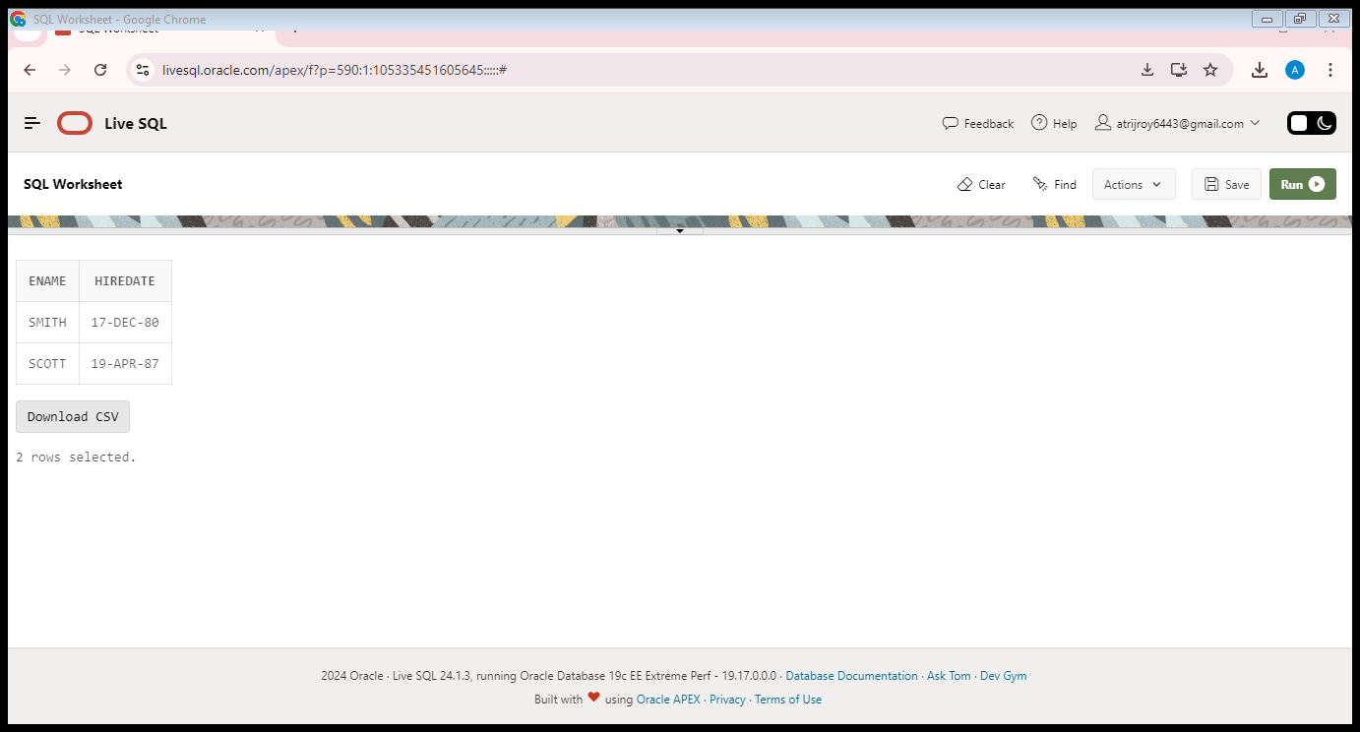

8. Show the name, hire date and salary of those employee who are not a manager.

**SELECT ENAME, HIREDATE, SAL FROM EMP WHERE JOB <> 'MANAGER';**

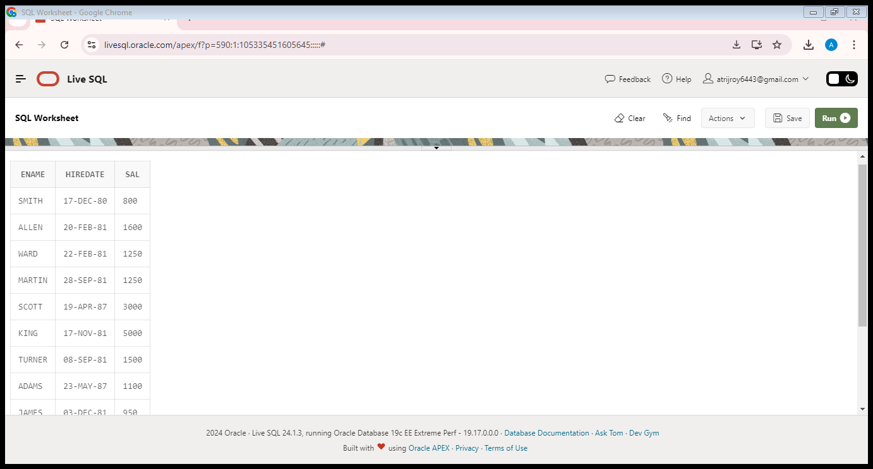

1. Display all employee names in title case and length of the name.

**SELECT INITCAP(ENAME) AS TITLE_CASE_NAME, LENGTH(ENAME) AS NAME_LENGTH FROM EMP;**

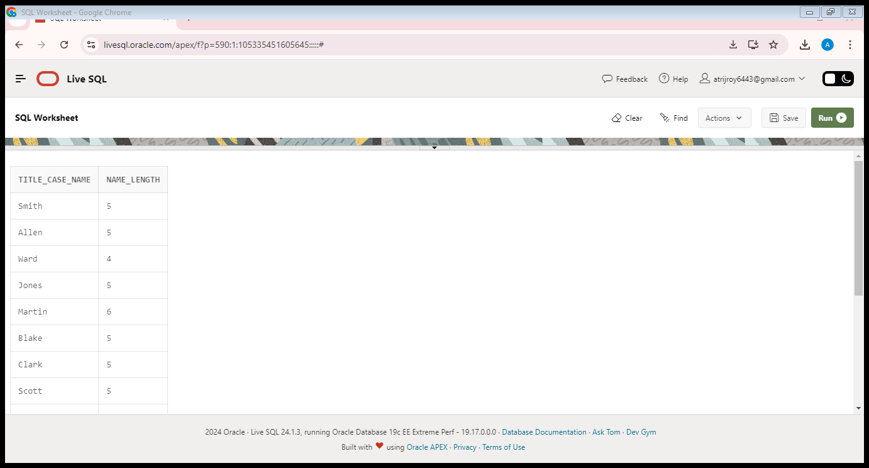

1. Display the name of the employee who gets the salary between 4000 and 6000.

**SELECT ENAME FROM EMP WHERE SAL BETWEEN 4000 AND 6000;**

